PROJECT AND TEAM INFORMATION

Project Title
FYOF(FIND YOUR OWN FOOD): Hassle-Free Food Management

Student / Team Information
Team Name: Team # | 4 Outliers
Team member 1 (Team Lead)  Aayush Saini (22011538)  aayushsaini915@gamil.com | 
Team member 2  Mohammad Areeb Amjad (220111676)  areeb.amjad24@gmail.com | 

Team member 3  Kanishka Bhandari (220121124)  kanishkaabhandari@gmail.com | 
Team member 4  Shalini Juyal (22021309)  shalinijuyal3@gmail.com | 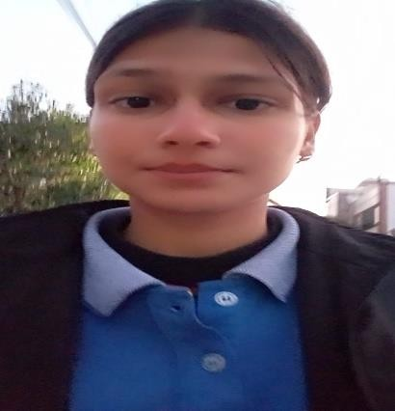

PROPOSAL DESCRIPTION (10 pts)

Motivation (1 pt)
Many students struggle to find affordable and convenient food options, especially when moving to a new area. Existing food services lack price comparisons, reviews, and availability details, making it difficult for students to make informed decisions. Our project aims to bridge this gap by providing an application that helps students locate mess facilities and food services based on pricing, availability, and quality.

State of the Art / Current solution (1 pt)
Currently, students rely on word of mouth, social media groups, or local listing websites to find mess and food options. However, these methods lack real-time data, price comparison, and feedback integration. Food delivery apps exist but do not cater specifically to student-friendly mess services and budget-oriented food options.
Project Goals and Milestones (2 pts)
The primary goal of this project is to develop a web based application where students can search for nearby mess and food services.
- Implement user reviews and ratings to enhance decision-making for students.
- Provide a recommendation system based on user preferences and budget constraints.
- Integrate OS algorithms for optimized searching and scheduling (e.g., shortest path for delivery routes, priority scheduling for meal availability).
- Develop a secure and scalable database to store vendor information, menus, and student preferences.
- Final Release – Deploy the application and provide extensive documentation for further enhancements.

Milestones:
Phase 1: Research and design UI/UX.
Phase 2: Develop the frontend using HTMl, CSS, ,React.js. Phase 3: Implement algorithm logic and integrate with UI. Phase 4: Testing and optimization.
Phase 5: Final release and documentation.

Project Approach (3 pts)
Frontend: HTML, CSS, React.js
Backend: Node.js, php
Algorithms: Scheduling Algorithm (Round Robin or Priority Scheduling for food delivery estimations), Shortest Path Algorithm (Dijkstra’s or A* for navigation).
Data Storage: MySQL / MongoDB Atlas
Deployment: Vercel / Netlify
System Architecture (2 pts)

- User Interface (UI):
  - View real-time pricing and availability
  - Submit reviews and ratings
- Algorithm Processing Module:
  - Shortest Path Algorithm (Dijkstra’s/A*) for navigation
  - Scheduling Algorithm (Round Robin/Priority Scheduling) for meal availability
3. Visualization Engine:
- Interactive charts for price comparison
- Heatmaps for peak meal times
4. Performance Metrics Module:
- Track food availability trends
- Analyze delivery time efficiency

Project Outcome / Deliverables (1 pts)
(Describe what are the outcomes / deliverables of the project. Max 200 words).
The final deliverables of this project will include:
- A functional web application for students to locate and compare mess services.
- A database of verified mess services and food providers with user ratings.
- An optimized search and scheduling system using OS algorithms.
- A fully deployed and documented application for further enhancements.

Assumptions
- The application will be primarily used by students in university areas.
- Mess owners and food vendors will be willing to register and update pricing and availability information.
- Users will actively provide ratings and reviews.
References

MDN Web Docs
React.js Official Documentation, GeeksforGeeks
Stack Overflow.

